Print Setup – Laptop
This only applies to personal devices, Salford Uni Laptops are already on the network.

Make sure your device is connected to UOS Wifi. Go to https://myprint.salford.ac.uk

Select ‘BYOD’ from the menu on the left hand side. Press ‘Download’. Once the download is complete run the installer.
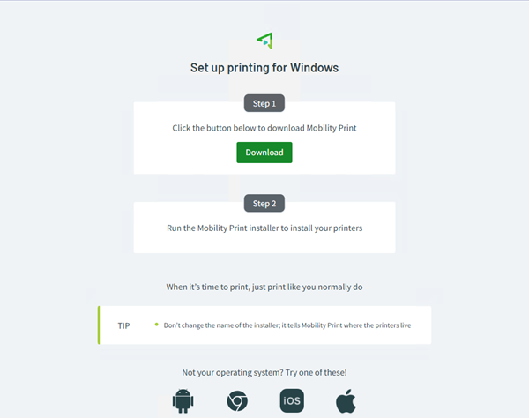

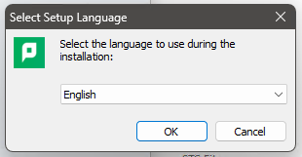

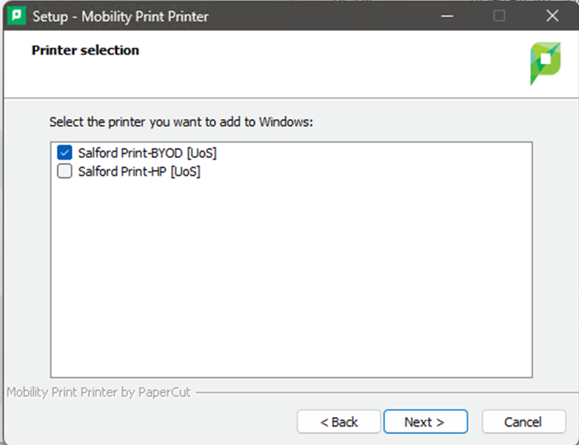

Make sure you have selected Salford Print-BYOD [UoS]. Press ‘Next’.

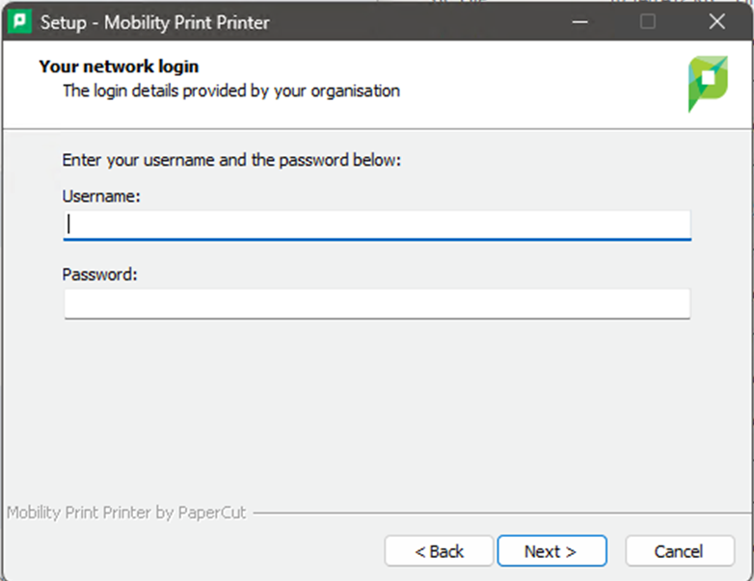

Use your UoS username and password.

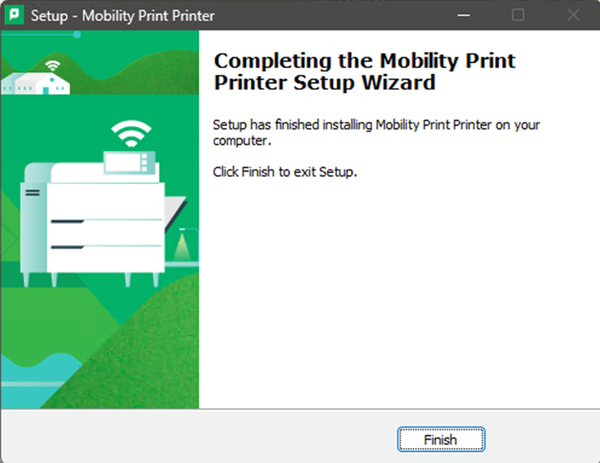
Press ‘Finish’.
Once this has been done you’re free to print. Simply choose ‘print’ in whichever app you’re using and you should see our printers listed.

Please Note: The first time you send a print job, you will be asked to sign in using your University Credentials. This is a one-time only task.

